1. We saw that we are free to define schema for our documents or structure documents the way we want for our use case or app.
2. **Agenda**: Let’s have a look at the data types available in mongodb.
3. **Types of Data**:  
   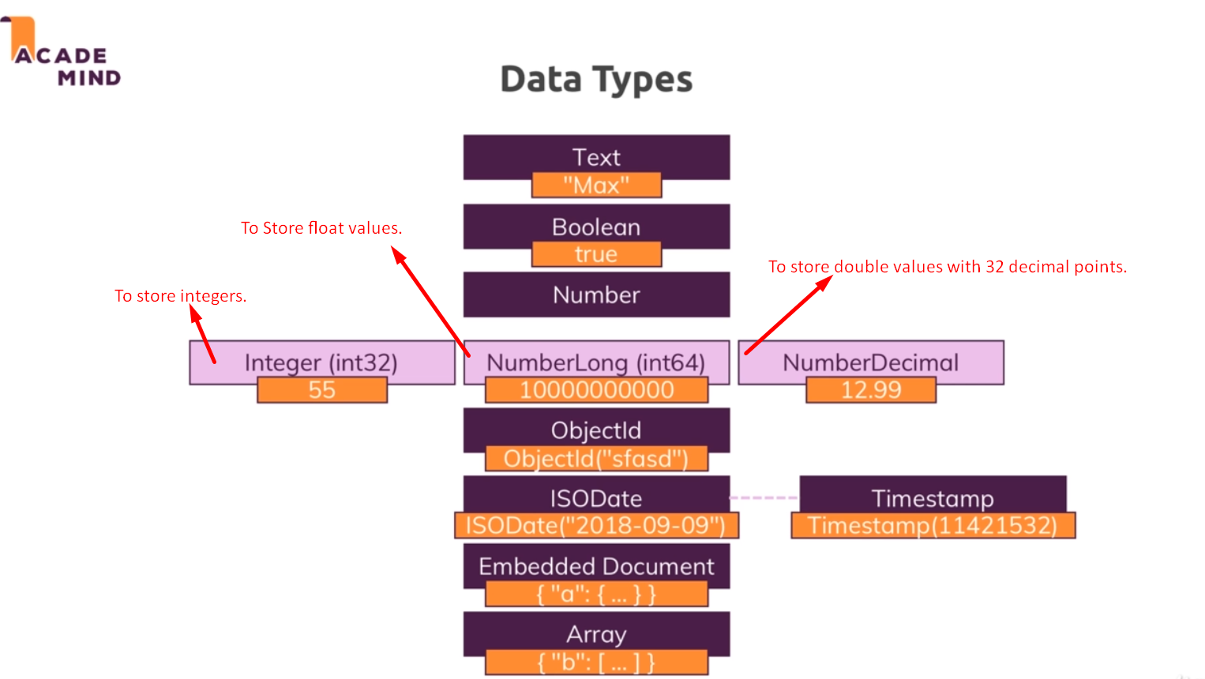
   1. **Text**:
      1. It uses the double quotation marks.
      2. Overall document size is 16mb.
   2. **Boolean**:
      1. True, false
   3. **Number**:
      1. **Integer**(int32):
      2. **NumberLong**(int64): For longer numbers. In the **shell**, when such numbers are entered, they are treated as **float values**.  
         This is because the normal shell as we use it in this course is based on javaScript and javascript doesn’t differentiate b/w integers and floating point values.  
         **Shell**: Shell is based on javascript but when you use mongodb from programming language, it’s strict about the type.   
         So from the shell “book”and ‘book’ values are same.
      3. **NumberDecimal:** This is to store higher precision floating point values because normal floating point values also called doubles are basically rounded, so they’re not super precise after their decimal place. If you’re doing scientific calculations or anything like that, you might need a very high precision with **34 decimal places** after the comma which are not rounded but guaranteed to be correct and precise. It’s simple a computing limitation that we got no 100% precision all the time but that rounding occurs.
      4. **ObjectID:** A bit more advanced. ObjectId object is a special object automatically generated by mongodb to give us a unique ID which is not just a unique random string but also a string that contains a **temporal component**, so that if you create two elements after each other, two documents after each other, you’re guaranteed to have the right order due to that ID because the older element will have an ID that comes prior to the other one. So there is this sorting built into the ObjectID because it respects a **timestamp**.
      5. **ISODate**: We can also save a date in DB. There is a special ISO date type. We can construct the date and save that to your database and that is then a date which you can work with to do a date calculations and so on.
      6. **Timestamp**: And there is also a timestamp used which is mostly internally. You can create it automatically, mostly you let mongoDB create that for you and that is guaranteed to be unique too.   
         **NOTE**: So even if you create two documents as the same time, they will not have exactly the same timestamp, because it will basically take into account the current time and then also add the **ordinal value**, so that two documents at the same time still don’t get the same time but respect the order in which the insert command was issued for example.   
         You could say that object kind of ObjectId is based on that timestamp and then just uses some algorithm to spit out a seemingly random string.
      7. **Embedded Document**: You can embed other documents and these documents can embed other documents.
      8. **Array**: List of values where values can be string, Boolean or embedded documents.
4. We have a module where we will discuss why we have these different types of numbers.